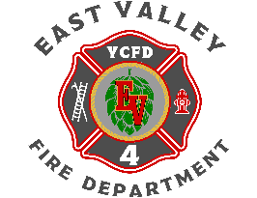
East Valley Fire Department
2003 Beaudry Road, Yakima, WA 98901
PHONE: 509.457.8615 FAX: 509.457.0373

BOARD OF COMMISSIONERS SPECIAL MEETING AGENDA
Yakima County Fire District #4
June 29th, 2026

- Opening of Meeting Start Time : Attendance:

- Pledge of Allegiance Brandt/St. Mary/Riel/Lamoureux/Munson/Roberts/Frost

- Executive Session: To evaluate the qualifications of an applicant for public employment or to review the performance of a public employee. However, subject to RCW 42.30.140(4), discussion by a governing body of salaries, wages, and other conditions of employment to be generally applied within the agency shall occur in a meeting open to the public, and when a governing body elects to take final action hiring, setting the salary of an individual employee or class of employees, or discharging or disciplining an employee, that action shall be taken in a meeting open to the public

- New Business
  - Final Employment Decision for DC Chris Munson
- Adjournment M: / 2: End Time :

***NOTICE***
Starting at 3:30 PM
Location: 2003 Beaudry Rd, Yakima WA 98901
Posted this 26^{th_}_ day of June , 2026 @ 3:30_ pm

