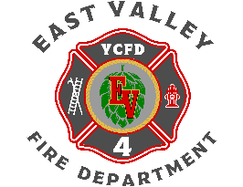

# 2025 BOFC Annual Planning Meeting

Agenda

June 6, 2025

0800 - 1200

* Executive Session
  + **RCW 42.30.110 (1)(g)**
* Status of Current Projects (Ray and Chris)
  + Negotiations
  + Training Tower
  + Station 40 Sub-Station
  + Tactical Tender
  + Command Vehicle
* 2025 Financial Update (Kaydee and Morgan)
* Commissioner Priorities for 2026 (Les, Ben, and Tyler)
* Draft 2026 Budget Presentation (Ray)
* Draft Strategic Plan Presentation (Ray)
* Operations / Training Report (Chris)
* 2026 Operational and Training Priorities (Chris)
* 2026 Fire Chief Priorities (Ray)
* Good of the Order
* Adjourn